Dynamic method (Theory)

Objective: To estimate volumetric mass transfer coefficient (K_{L}a) by dynamic method.

Theory: Oxygen acts a limiting nutrient for an aerobically growing culture in the bioreactor. Even in a reactor having non limiting availability of normal Carbon, Nitrogen and other sources, the limiting or no availability to aerobically growing culture may lead to death of the microbial population in no time. Therefore the air (oxygen) has to be adequately supplied either by sparger or in head space to enhance the dissolved oxygen so that microorganisms are able to breathe through the pores. It is important to note that the capacity of water to retain oxygen is rather limited. Under the normal condition of 25º C and 1 Atmosphere pressure, the dissolved oxygen will be 8 mg/L. Air has to be continuously purged and agitated so as to enhance the depleting oxygen in the bioreactor. For adequately aerated cultivation, the supply of oxygen has to be greater than the demand of the culture to maintain the healthy growth & metabolite production by the microorganisms at any point of time. Assume that the bioreactor is in well mixed condition and dissolved oxygen concentration is constant through-out the reactor, the following equation will hold true.

Rate of dissolution of dissolved oxygen (dC_{L}/dt) = {Supply of oxygen (K_{L}a (C*– C_{L})} – {Demand by microorganism (rX)}

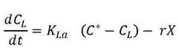

Where, ‘K_{L}a’ is termed as volumetric mass transfer coefficient or ‘aeration efficiency’, C* saturation concentration of dissolved oxygen, C_{L} is the dissolved oxygen concentration in the bulk of the fermentation broth, ‘r’ is respiratory rate constant and ‘X’ is available biomass (g/L).

This measurement technique for aeration efficiency is dependent on actively growing culture in bioreactor in which aeration is stopped and decrease in dissolved oxygen due to respiration of the cells is measured by a fast response Dissolved Oxygen probe to estimate the rate of oxygen uptake by the total available microbial population. Dissolved oxygen concentration is recorded before a critical level is reached. Thus when aeration is stopped

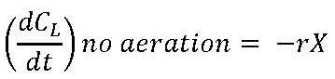

Upon resumption of aeration

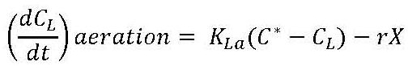

Which can be rearranged to give C_{L} as follows:

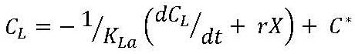

Therefore a plot of C_{L} vs (dC_{L} / dt + rX) on arithmetic coordinates will give linear relationship and from this the slope is (-1/K_{L}a) & C* is the intercept on the y axis. Therefore K_{L}a and C* can be determined.

